DBT Assignment 7
- Write a query that lists each order number followed by the name of the customer who made the order.
- SELECT o.onum, c.cname FROM orders o INNER JOIN customers c ON o.cnum = c.cnum GROUP BY o.onum, c.cname;
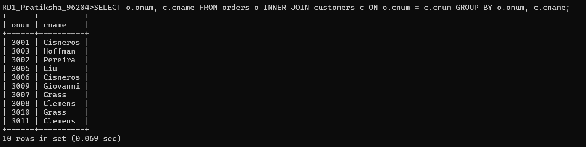

- Write a query that gives the names of both the salesperson and the customer for each order along with the order number.
- SELECT s.sname, c.cname, o.onum FROM customers c INNER JOIN orders o ON c.cnum = o.cnum INNER JOIN salespeople s ON o.snum = s.snum;
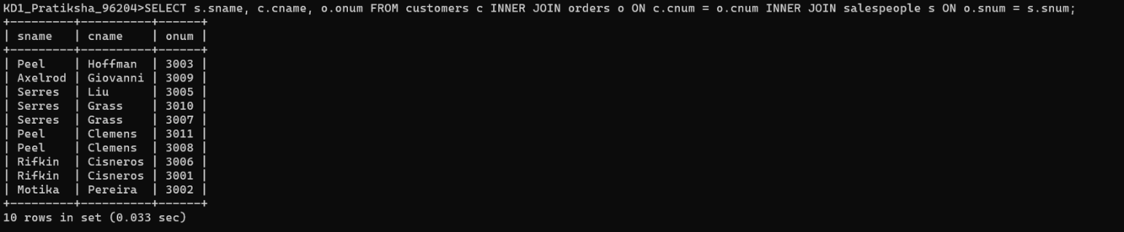
- Write a query that produces all customers serviced by salespeople with a commission above 12%. Display the customer’s name, the salesperson’s name, and the salesperson’s rate of commission.
- SELECT c.cname, s.sname, s.comm FROM customers c INNER JOIN salespeople s ON c.snum = s.snum WHERE s.comm > .12;
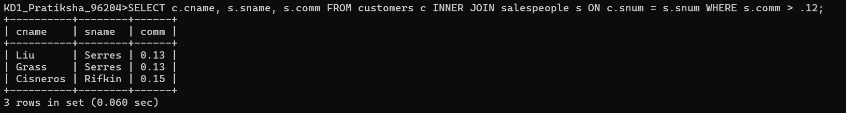
- Write a query that calculates the commission earned by each salesperson for orders placed by customers with a rating above 100.
- SELECT s.sname, o.onum, o.amt * s.comm AS Commission_Earned FROM salespeople s JOIN customers c ON s.snum = c.snum JOIN orders o ON c.cnum = o.cnum WHERE c.rating > 100;
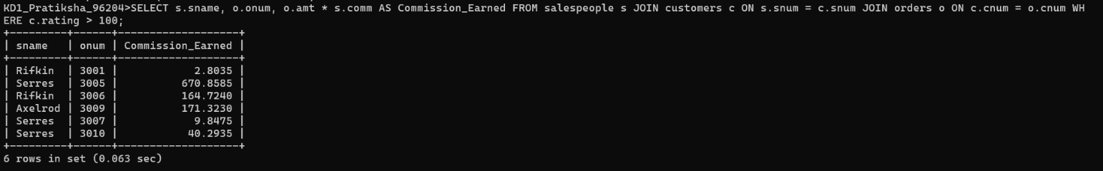
- Write a query that produces all pairs of salespeople who are living in the same city. Exclude combinations of salespeople with themselves as well as duplicate rows with the order reversed .
- SELECT s1.sname, s2.sname FROM salespeople s1 INNER JOIN salespeople s2 WHERE s1.city = s2.city AND s1.sname < s2.sname;

